PROJECT Deadline Remainder System
A Mini Project Report Submitted in the partial fulfillment of the requirements for the award of the degree of

BACHELOR OF TECHNOLOGY

In
DEPARTMENT OF COMPUTER SCIENCE ENGINNERING
and
DEPARTMENT OF COMPUTER SCIENCE AND INFORMATION TECHNOLOGY
By
Pranay Sangam– 2420090115(Team Lead)
Jatin Ponam – 2420030032
Aluru Sri Tejaswi Priyank – 2420030276

Under the Esteemed Guidance of

Name of the SOA faculty of respective section
Dr.Neelima Gogineni,
Assistant Professor





K L (Deemed to be) University
DEPARTMENT OF COMPUTER SCIENCE ENGINEERING

DECLARATION

The Mini Project Report entitled “Project Deadline Remainder System “is a record of Bonafide work of Pranay Sangam – 2420090115, Jatin Ponam – 2420030032, Aluru Sri Tejaswi Priyank – 2420030276. submitted in partial fulfillment for the award of B. Tech in Computer Science and Engineering and Computer Science and Information Technology to the K L University. The results embodied in this report have not been copied from any other departments/University/Institute.

Pranay Sangam – 2420090115
Jatin Ponam – 2420030032
Aluru Sri Tejaswi Priyank – 2420030276

K L (Deemed to be) University
DEPARTMENT OF COMPUTER SCIENCE ENGINEERING
and
DEPARTMENT OF COMPUTER SCIENCE AND INFORMATION TECHNOLOGY
CERTIFICATE

This is certify that the mini project based report entitled “Project Deadline Remainder System” is a bonafide work done and submitted by Pranay Sangam – 2420090115, Jatin Ponam – 2420030032, Aluru Sri Tejaswi Priyank – 2420030276 in partial fulfillment of the requirements for the award of the degree of BACHELOR OF TECHNOLOGY in Department of Computer Science Engineering and Department of Computer Science and Information Technology K L (Deemed to be University), during the academic year 2026-2027.

Signature of the Course Co-ordinator Signature of HOD

ACKNOWLEDGEMENT

The success in this project would not have been possible but for the timely help and guidance rendered by many people. Our wish to express my sincere thanks to all those who has assisted us in one way or the other for the completion of my project.

Our greatest appreciation to my guide, Dr.Neelima Gogineni, Department of Computer Science Engineering which cannot be expressed in words for her tremendous support, encouragement and guidance for this project.

We express our gratitude to Dr. P.Venkateshwar Sir (CSE) and Dr. Kaja Shareef Sir (CSIT), Head of the Department for Computer Science Engineering and Department for Computer Science and Information Technology for providing us with adequate facilities, ways and means by which we are able to complete this project-based Lab.

We thank all the members of teaching and non-teaching staff members, and also who have assisted me directly or indirectly for successful completion of this project. Finally, I sincerely thank my parents, friends and classmates for their kind help and cooperation during my work.

Pranay Sangam – 2420090115
Jatin Ponam – 2420030032
Aluru Sri Tejaswi Priyank -2420030276

TABLE OF CONTENTS

S.No. | Contents | Page no.
1. | Abstract | 1
2. | Introduction | 2
3. | Literature survey | 3
4. | Problem Statement and Objectives | 4
5. | Hardware and Software requirements | 5
6. | Implementation | 6
7. | Results & Discussion | 7
8. | Conclusion & Future Scope | 8
9. | References | 9

- ABSTRACT

The Project Deadline Reminder System is a simple software application developed to help users manage their projects and remember important deadlines. Students often have multiple assignments, lab records, exams, and project submissions to complete within a specific time,sometimes, they may forget the due dates or fail to complete their work on time. This project aims to solve this problem by providing an easy way to manage tasks and receive deadline reminders.
The system allows users to add tasks, set deadlines, and check the status of their work. It helps users identify upcoming deadlines and tasks that are overdue. Reminders are provided to notify users about tasks that need to be completed. Users can also update the status of tasks as pending, in progress, or completed. All task details are organized in one place, making it easier to manage and track daily activities.
The system is developed using suitable programming tools and a database to store task details and deadlines. The main goal of this project is to reduce the chances of missing deadlines and improve time management. It also helps users plan their work properly and complete tasks according to their schedule. Overall, the Project Deadline Reminder System provides a simple and useful solution for managing tasks, tracking deadlines, and improving productivity in academic and professional activities.
Team Name: Project Deadline Reminder System - 15

Team Logo (if any):

Team Members:
- Pranay Sangam
- Jatin Ponam
- Aluru Sri Tejaswi Priyank

- INTRODUCTION

In today's busy world, students and professionals need to manage multiple tasks and complete them within specific deadlines. Students often have assignments, lab records, examinations, and project submissions to complete on time. Managing all these activities can sometimes be difficult, and people may forget important due dates or delay their work. This can lead to incomplete tasks and unnecessary stress. So a simple system is needed to help users organize their tasks and remember their deadlines.
The Project Deadline Reminder System is developed to help users manage their tasks and track important deadlines in one place. It allows users to add tasks, set due dates, view upcoming deadlines, and update the status of their work. The system also provides reminders about approaching deadlines so that users can plan their work and complete tasks on time. Users can easily identify pending, ongoing, and completed tasks.
The main purpose of this project is to reduce the chances of missing deadlines and improve time management. Instead of depending on memory or maintaining task details manually, users can use this system to organize their work more effectively. The application aims to provide a simple, user-friendly, and useful way to manage daily tasks and project activities.
This project report explains the problem statement, objectives, existing system, proposed system, technologies used, system design, implementation, testing, and conclusion with future enhancements.

- LITERATURE SURVEY

1. Microsoft To Do
Microsoft To Do is an application used to create and manage tasks. It allows users to set due dates and reminders for their tasks. Its Planned list helps users view tasks scheduled for today, tomorrow, and later dates. This application is useful for understanding how task scheduling and deadline reminders can be implemented.
2. Trello
Trello is a project management application that organizes work using boards and cards. Users can add due dates to cards and configure reminders for upcoming deadlines. It also supports recurring due dates for repeated tasks. These features make it a useful reference for designing a project deadline tracking system.
3. TickTick
TickTick is a task management application that provides lists, filters, and reminder features. Users can set reminders for specific times and configure recurring reminders. The application also provides calendar features for planning tasks. It can be studied to understand how reminders and task organization help users manage their schedules.
4. Notion
Notion is a workspace application that allows users to organize information and manage tasks. Its reminder feature can notify users about a task, event, or page at a specified date or time. Users can also configure reminders for dates stored in databases. This provides an example of combining task information and reminders in a single workspace.

5. Remember The Milk
Remember The Milk is a task management application that helps users organize their activities. It allows users to add reminders to individual tasks and choose when to receive notifications in relation to a task's due date or time. Users can also configure multiple reminders for a task. This application provides a reference for implementing deadline-based notifications.
Official references
Microsoft To Do — Official documentation
Trello — Official documentation
TickTick — Official features page
Notion — Official documentation
Remember The Milk — Official reminder documentation

- Problem Statement and Objectives

Problem Statement: Managing multiple tasks and remembering their deadlines can be difficult, leading to missed submissions and delays therefore, a simple system is needed to track tasks and provide timely reminders.

Problem Description: Students and professionals often struggle to manage multiple tasks and remember their deadlines. A simple system is needed to organize tasks, send timely reminders, and track task completion.

Objectives:
Identify the Project's Purpose:
To develop a simple system for adding and managing tasks.
To allow users to set deadlines for their tasks and projects.
To provide timely reminders about upcoming deadlines.
To help users identify pending, ongoing, and completed tasks.
To reduce missed deadlines and improve time management.
To provide a user-friendly interface for tracking tasks in one place.

- HARDWARE AND SOFTWARE REQUIREMENTS
Hardware Requirements:
Processor: Intel Core i3 or equivalent and above
RAM: Minimum 4 GB
Hard Disk: Minimum 256 GB

Software Requirements:
- Operating System: Windows 10/11
- Programming Language: Java or Python
- Frontend: HTML, CSS, JavaScript
- Database: MySQL

- IMPLEMENTATION
1. Frontend: HTML, CSS, JavaScript
Frontend: HTML, CSS, JavaScript
- index.html: Contains the user interface for adding tasks, entering deadlines, viewing upcoming deadlines, and displaying reminders.
- style.css: Defines the design, layout, colors, buttons, forms, and responsive styling.
- script.js: Handles task creation, deadline management, input validation, and displaying reminders.
- dashboard.html (optional): Displays all tasks, completed tasks, and pending deadlines.
- login.html (optional): Provides a login page if user authentication is implemented.
2. Backend: Java
Backend: Java with Spring Boot
- DeadlineReminderApplication.java: Main class to start the Spring Boot application.
- Deadline.java: Entity class that stores task details, deadline date, description, and task status.
- DeadlineController.java: Handles REST API requests for creating, viewing, updating, and deleting deadlines.
- DeadlineService.java: Contains the business logic for managing deadlines and checking upcoming reminders.
- DeadlineRepository.java: Interface for database operations using Spring Data JPA.
- ReminderService.java: Checks upcoming deadlines and triggers reminder notifications.
- application.properties: Configures the server port and database connection.
Database: MySQL or PostgreSQL can be used to store task details and deadlines.
3. API Integration
API Integration: Connects the frontend with the Java Spring Boot backend through REST APIs.
- script.js: Uses JavaScript fetch() to send requests to the backend and retrieve deadline information.
- DeadlineController.java: Provides REST API endpoints for communication between the frontend and backend.
- ReminderService.java: Handles deadline checking and reminder triggering.
- EmailService.java (optional): Integrates an email service to send deadline notifications.
- CorsConfig.java (optional): Configures CORS to allow the frontend to communicate with the backend when hosted on a different origin.

- RESULTS & DISCUSSION
Output website screen shots with their explanation in 2 lines.

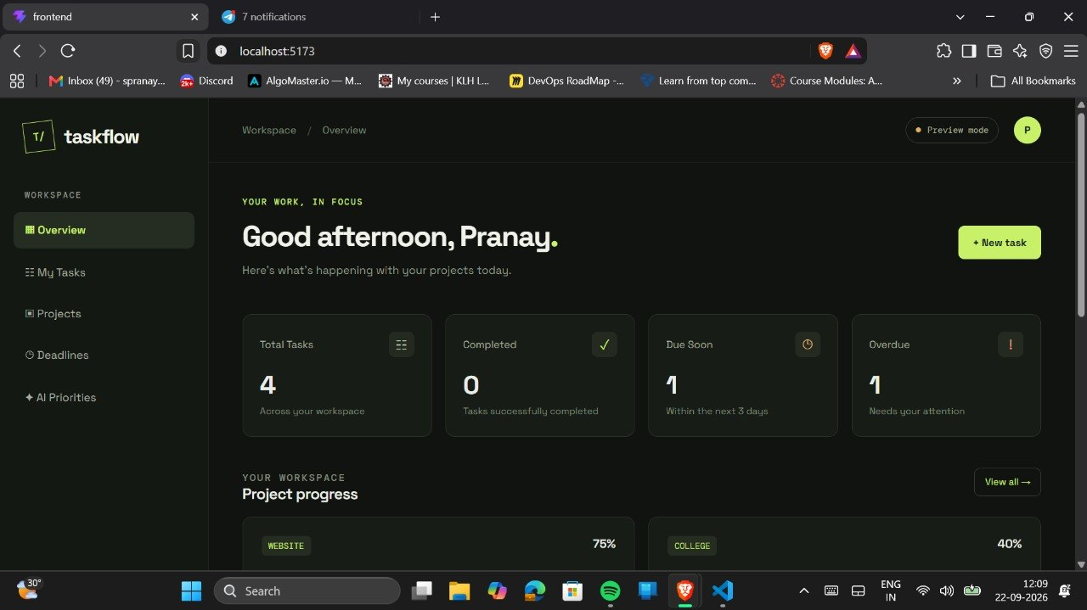
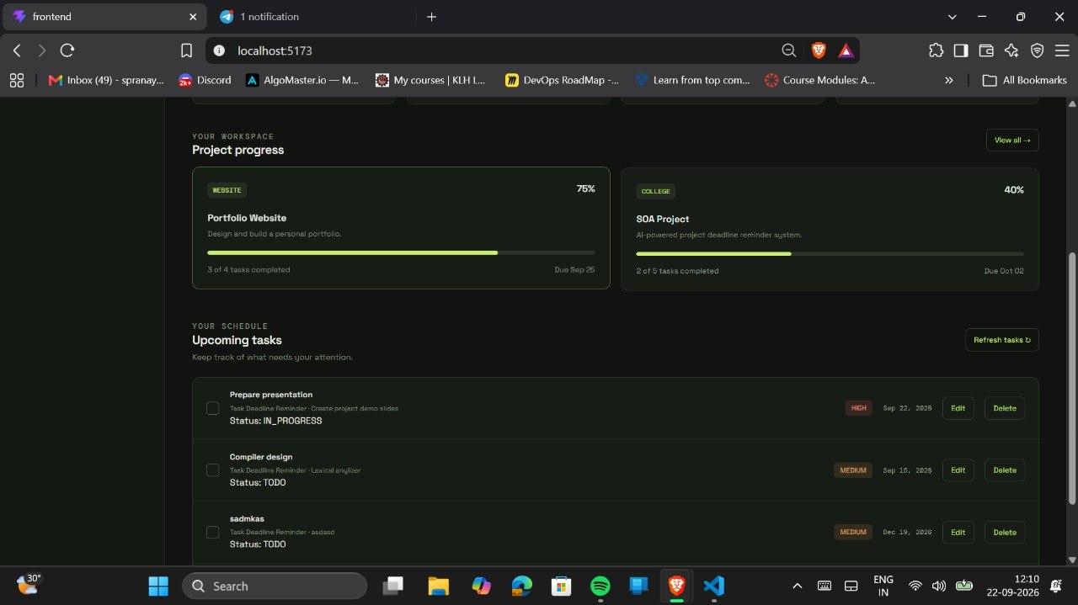
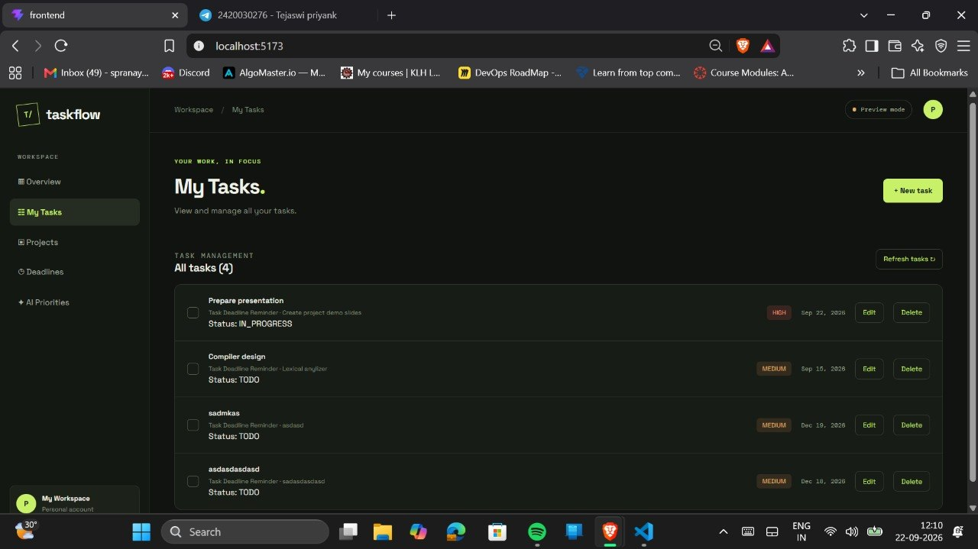
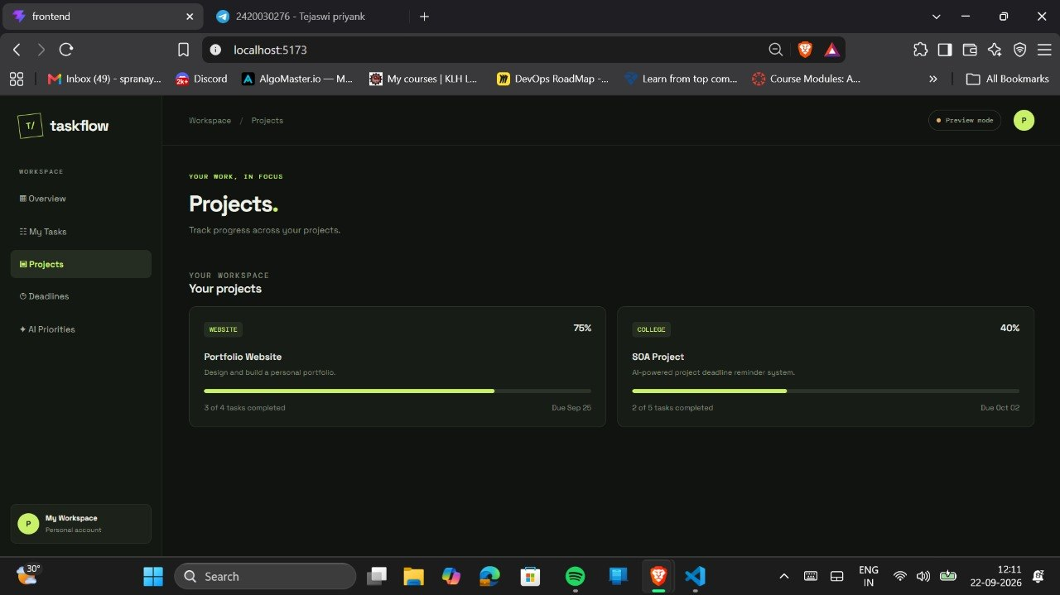
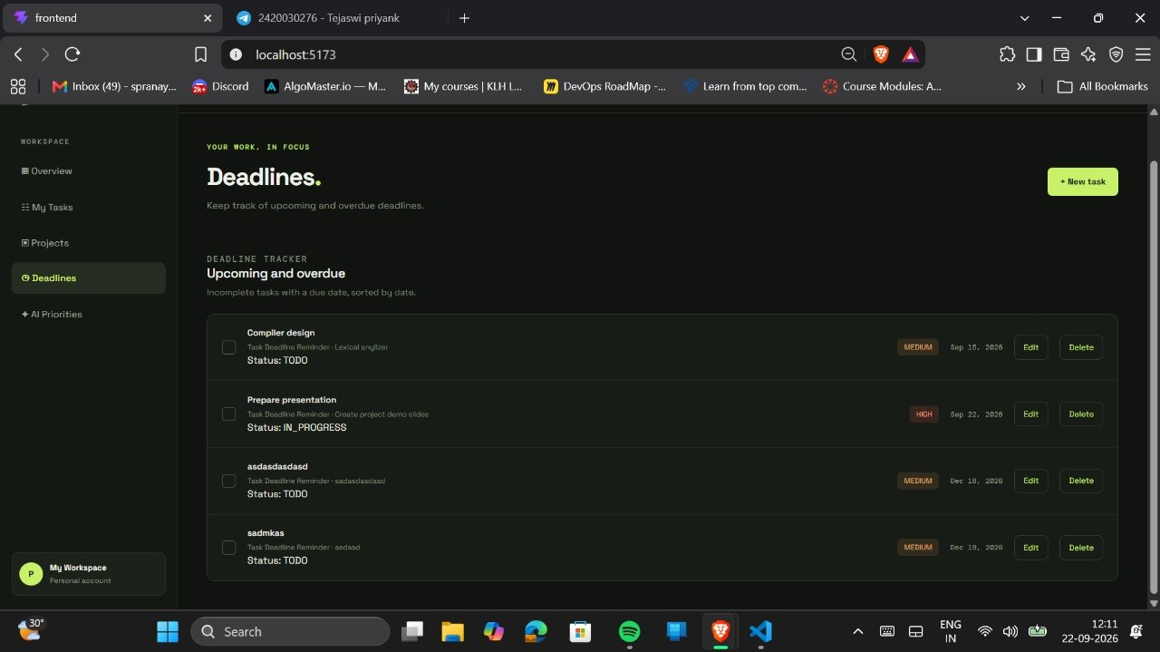
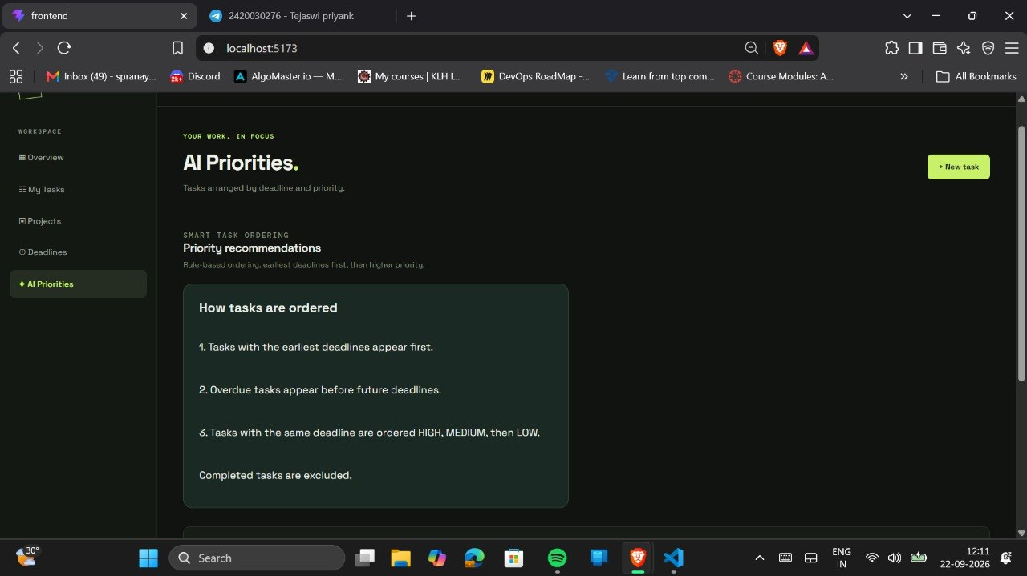
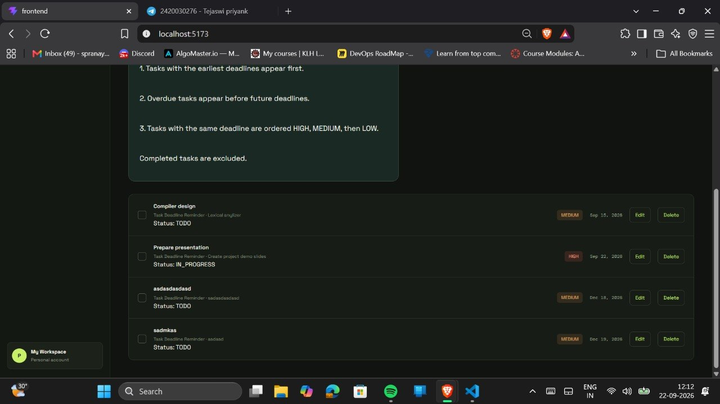
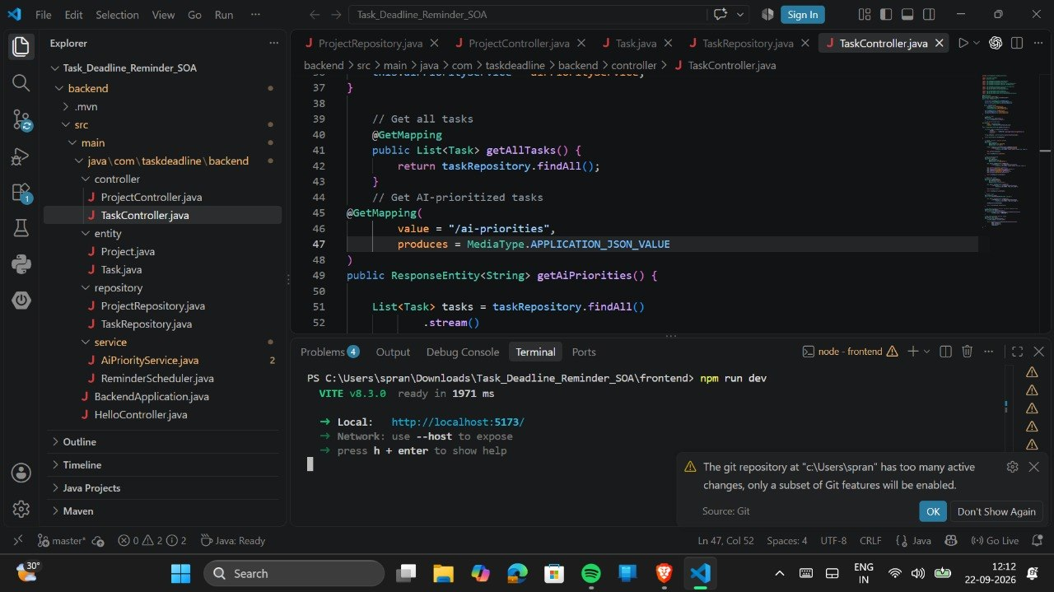
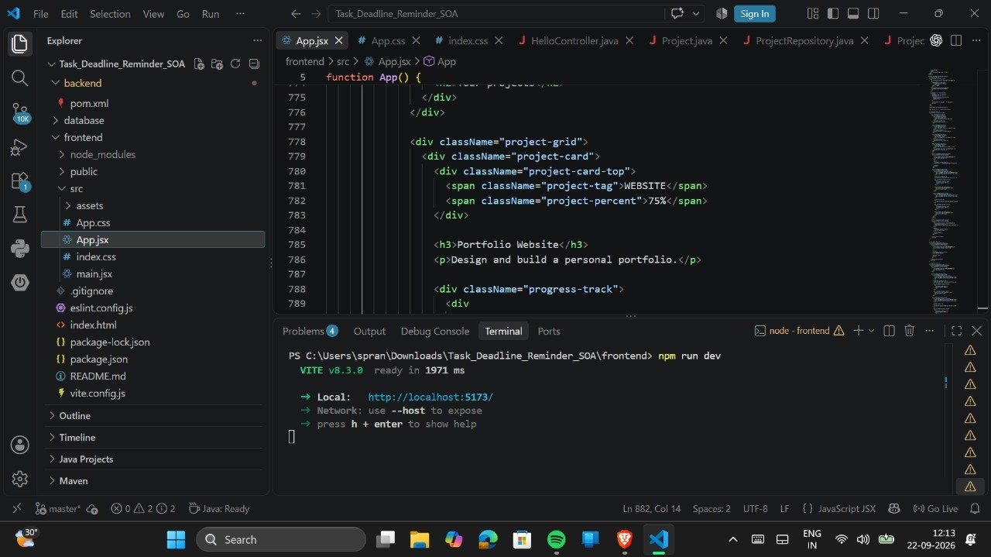
The Deadline Reminder System provides a dashboard to manage tasks, projects, deadlines, and task priorities, with options to add, edit, delete, and track task status.

- CONCLUSION & FUTURE SCOPE
Conclusion
The Project Deadline Reminder System is designed to help users manage their tasks and remember important deadlines. It allows users to add tasks, set due dates, receive reminders, and track task status. The system aims to reduce the chances of missing deadlines and helps users organize their work efficiently. This project provides a simple and user-friendly solution for improving time management and completing tasks on time.
Future Scope
The Project Deadline Reminder System can be improved in the following ways:
- Email and SMS Notifications: Send reminders to users through email or SMS.
- Mobile Application: Develop a mobile app so users can manage their tasks from anywhere.
- Priority Management: Allow users to assign priorities to tasks based on their importance.
- Calendar Integration: Connect the system with a calendar to display upcoming deadlines.
- Progress Reports: Generate reports showing completed, pending, and overdue tasks.
- Smart Reminders: Provide suggestions for planning tasks based on their deadlines and priority.

- REFERENCES

- Microsoft To Do, Official Website. https://www.microsoft.com/en-in/microsoft-365/microsoft-to-do-list-app
- Microsoft Support, “Add Due Dates and Reminders in Microsoft To Do.” https://support.microsoft.com/en-us/todo/add-due-dates-and-reminders-in-microsoft-to-do
- Trello, Official Website. https://trello.com/
- Atlassian Support, “Adding Dates to Cards.” https://support.atlassian.com/trello/docs/adding-dates-to-cards/
- TickTick, Official Features Page. https://ticktick.com/features
- Notion, Official Website. https://www.notion.com/
- Notion Help Center, “Reminders.” https://www.notion.com/help/reminders
- Remember The Milk, Official Website. https://www.rememberthemilk.com/
- Asana, Official Website. https://asana.com/
- ClickUp, Official Website. https://clickup.com/

